Please follow these instructions to proceed with the installation of your extension:

#1 Installation:
- Copy all files into your magento directory and turn Magento cache off.
- In case you have different then "default" default folder - copy extensions folders to your default theme
- Navigate to System > Configuration > Wagento > Transfer Content Integration.

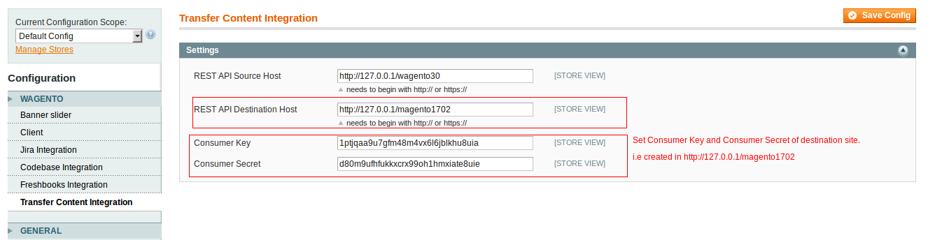

#2 Consumer key and Secret key(Create in Website B)
1) First we want to register an Oauth consumer to get the consumer key and secret key.
2) Login to the admin of the magento shop and from the menu
System->Web Services->REST - Oauth Consumers and add a new Ouath consumer.
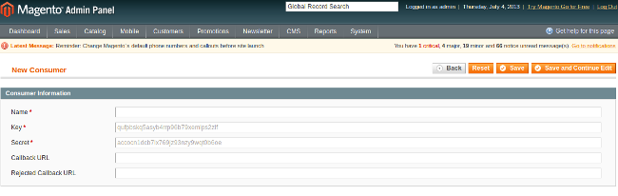

3) We need the Key and Secret which is what we pass in the
System > Configuration > Wagento > Transfer Content Integration.

#3 Creating a REST role for the Content Tranfer Api(Create in Website B)
1) Click System > Web Services > REST – Roles.
2) On the REST—Roles page, click Add Admin Role.
3) In the Role Name field, enter Content Transfer Demo.
4) Click Save Role.
5) In the left navigation bar, click Role API Resources.
6) The Role Resources page contains a hierarchical list of resources to which you can grant or deny the Content Transfer Demo role access.
7) From the Resource Access list, click Custom.
8) Select the check box next to the node labeled Content Transfer API.

Magento automatically checks the child check boxes as the following figure shows.
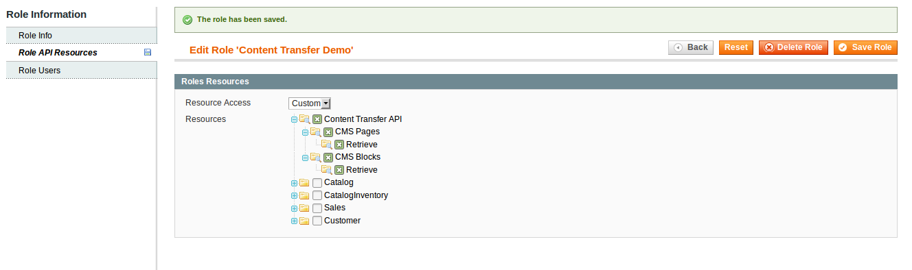
9) Click Save Role.
Magento saves the resource API permissions you granted to the Content Transfer Demo REST role.
The Content Transfer Demo role now has permission to use the Cms Pages and Cms Static Blocks.
10) In the left navigation bar, click Role Users. Click Reset Filter (in the upper-right corner of the page).
The page displays all registered users as the following figure shows.
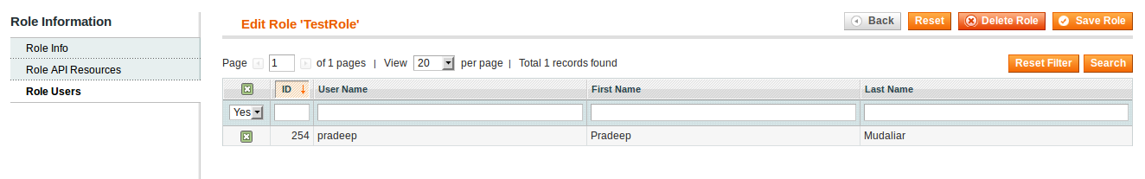

11) Select the check box next to each user to grant the user privileges to access the resources available to the Content Transfer Demo REST role—that is, permission to call the Content Transfer API.
12) When you're done, click Save Role.
The specified user(s) can now grant an external program the right to call the Content Transfer API.

#4 System Configuration
Navigate to System > Configuration > Wagento > Transfer Content Integration.

- REST API Source Host – Website A Host Name.
- REST API Destination Host – Website B Host Name.
- Consumer Key - Website B consumer key for oauth authentication.
- Consumer Secret - Website B consumer Secret for oauth authentication.

#5 Running the Module(In Website A)
- Navigate CMS >> Pages.
- Click Sync Pages (in the upper-right corner of the page).
- It will redirect to Website B and prompt login screen.
- Enter the login credentials of the OAuth consumer.
- Click Login.
- When prompted, click Authorize to grant authorization for the script to access your OAuth consumer account, as the following figure shows.
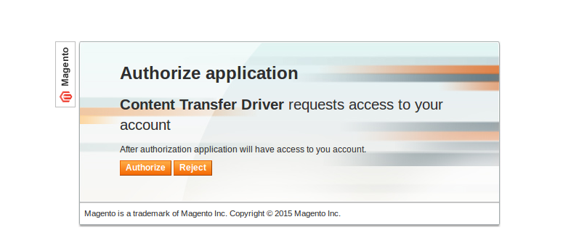
- Click Authorize, this update all the Cms Pages content from Website B to Website A

8. To update Cms Static Blocks, Please follow same steps after navigation to CMS >> Static Blocks.

